Taras Lehinevych, Nikolaos Kokkinis-Ntrenis. Discovering similarities for content-based recommendation and browsing in multimedia collections,
Main research question:
- This paper is to examine the existence of correlation between low level audio, visual and textual features and movie content similarity.
- three similarity matrices (one for each medium) have been computed based on Gaussian Mixture Models (audio and visual) and Latent Semantic Indexing (text).
-We have evaluated the automatically extracted similarities along with two simple fusion approaches and results indicate that the low-level features can lead to an accurate representation of the movie content. In addition, the fusion approach seems to outperform the individual modalities, which is a strong indication that individual modules lead to diverse similarities (in terms of content).
- Finally, we have evaluated the extracted similarities for different groups of human annotators, based on what a human interprets as similar and the results show that different groups of people correlate better with different modalities.
-This last result is very important and can be either used in (a) a personalized content-based retrieval and recommender system and (b) in a “local” weighted fusion approach, in future research.
Methodology
This paper extract three domain features audio, visual and text as content-based features. After that it added user preferences features as total features frame.
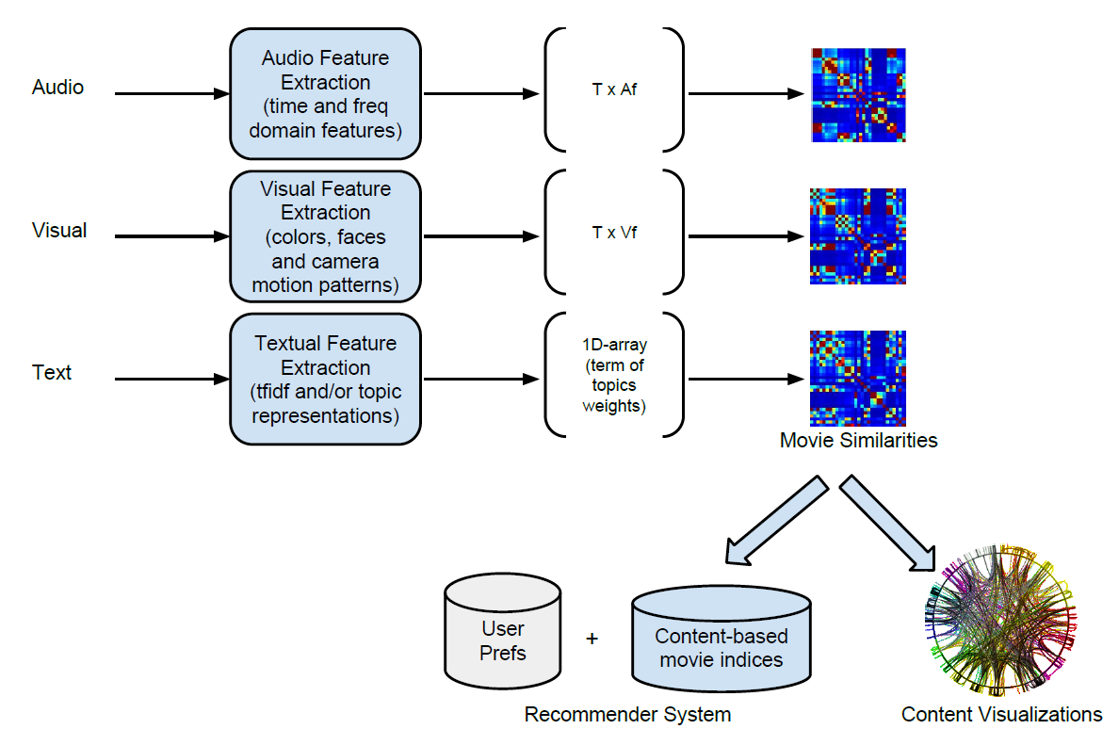
- Audio and visual similarity
The audio signal into 40-msec non-overlapping short-term frames and extract the following features from each frame:
_ Energy
_ Zero Crossing Rate
_ Energy Entropy
_ Spectral centroid, spread, entropy, flux, and roll-off
_ Mel-Frequency Cepstrum Coefficients (MFCCs)
The visual channel may contain important information regarding the type of movies and particular movie scenes.
- RGB-based histograms.
- Intensity histogram.
- Average intensity difference.
- Face information:
- Camera motion information.

